SIMATS ENGINEERING (SAVEETHA SCHOOL OF ENGINEERING)
Department of Computer Science and Engineering
ASSESSMENT TOOL 1 – RAG-BASED MINI ASSIGNMENT (DOCUMENT QA / AI AGENT DEMO)

Course Code: | CSA65 | Course Title: | Generative AI and Large Language Models
CO Assessed: | CO3 – Precision (BL2, BL3) | Assessment: | Assessment Tool 2 – RAG-based Mini Assignment (Document QA / AI Agent Demo)
Weightage: | 20% of CIA | Total Marks: | 2 * 50 = 100 (1 Question1)
CO3 Statement: | Develop intelligent applications using Retrieval-Augmented Generation (RAG), vector databases, and introductory AI agent concepts.(BL3, BL4)
Student Name: | V. Venkata Karthik Reddy | Reg. No.: | 192472241
Section / Batch: | 2024 | Date: | 8-8-2026

Instructions to Students
- Answer 2 questions. Each question carries 50 marks.Total: 100 Marks.
· Implement the solution using Python.
· Use an appropriate LLM such as OpenAI, Gemini, or Hugging Face.
· Use embeddings and semantic search where applicable.
· Use FAISS or ChromaDB as the vector database for RAG tasks.
· Demonstrate the complete pipeline:
Document → Chunking → Embedding → Retrieval → Generation
· Demonstrate the system with multiple queries.
· Handle irrelevant, incomplete, or unsupported queries appropriately.
· Display retrieved context/source wherever applicable.
· Explain the system architecture.
· Provide a working end-to-end demonstration.

Code of Conduct
I V. Venkata Karthik Reddy (192472241) certify that this submission is my original work and that I have adhered to the guidelines specified for this assessment. I understand that any violation of academic integrity rules will result in disciplinary action.
Signature of the Student: Karthik Reddy

SECTION A – RAG-BASED MINI ASSIGNMENT (DOCUMENT QA / AI AGENT DEMO)
33. College Helpdesk AI Agent: Develop an AI agent for admission, fees, courses, examinations, attendance, and general FAQ queries using appropriate tools or knowledge sources.
38. Multi-Document Enterprise RAG Assistant: Develop an enterprise RAG assistant using PDF, DOCX, and TXT documents. Combine information from all documents and answer user questions.

ANSWERS:

Title
AI-Powered College Helpdesk Agent for Admissions, Fees, Courses, Examinations, Attendance, and FAQs

Objective
To develop an intelligent AI agent that answers student queries related to admission procedures, fee details, course information, examination schedules, attendance policies, and general college FAQs using Retrieval-Augmented Generation (RAG).

Problem Statement
Students frequently ask repetitive questions regarding college services. Manual support consumes time and resources. An AI-based helpdesk can provide instant and accurate responses using institutional documents.

Knowledge Sources
- College Admission PDF
- Fee Structure Document (DOCX)
- Course Handbook (PDF)
- Examination Regulations (PDF)
- Attendance Rules (TXT)
- FAQ Document

Tools Used
- Python
- LangChain
- FAISS / ChromaDB
- OpenAI / Gemini API
- PyPDF2
- python-docx
- Text Loader
- Streamlit / Gradio

System Architecture
User Query
↓
AI Agent Interface
↓
Document Loader (PDF/DOCX/TXT)
↓
Text Chunking
↓
Embedding Model
↓
Vector Database (FAISS/ChromaDB)
↓
Retriever
↓
LLM (GPT/Gemini)
↓
Final Answer

Working Process
Step 1: Document Collection
Collect admission, fee, examination, and attendance documents.
Step 2: Text Extraction
Extract content from PDF, DOCX, and TXT files.
Step 3: Chunking
Split large documents into smaller chunks.
Step 4: Embedding Generation
Convert text chunks into vector embeddings.
Step 5: Storage
Store embeddings in FAISS or ChromaDB.
Step 6: Retrieval
Find relevant information for user queries.
Step 7: Response Generation
LLM generates accurate answers using retrieved content.
Example Queries
User Question | AI Response
What is the admission deadline? | Retrieves admission document details
What is the fee for CSE? | Retrieves fee information
What is the attendance requirement? | Retrieves attendance rules
When are examinations conducted? | Retrieves exam schedule

Sample Python Code:

# College Helpdesk AI Agent

knowledge = {
"admission": "Admission applications are accepted online. Students must submit the required certificates before the deadline.",
"fees": "The semester fee depends on the course. Students should check the latest fee structure provided by the college.",
"courses": "The college offers courses such as Computer Science, Artificial Intelligence, Electronics and Mechanical Engineering.",
"exam": "Examinations are conducted according to the academic calendar. Students must carry their valid ID card.",
"attendance": "Students are expected to maintain the minimum attendance requirement specified by the college.",
"library": "The library is available to students during college working hours.",
"hostel": "Hostel facilities are available for eligible students based on availability.",
"placement": "The placement cell conducts training, aptitude tests, interviews and campus recruitment activities."
}

def search_answer(question):
question = question.lower()

for keyword, answer in knowledge.items():
if keyword in question:
return answer

return "Sorry, I could not find the answer in the college knowledge base."

print("====================================")
print(" COLLEGE HELPDESK AI AGENT")
print("====================================")
print("Type 'exit' to stop.\n")
while True:
question = input("Student: ")

if question.lower() == "exit":
print("Thank you!")
break
answer = search_answer(question)
print("AI Agent:", answer
print()
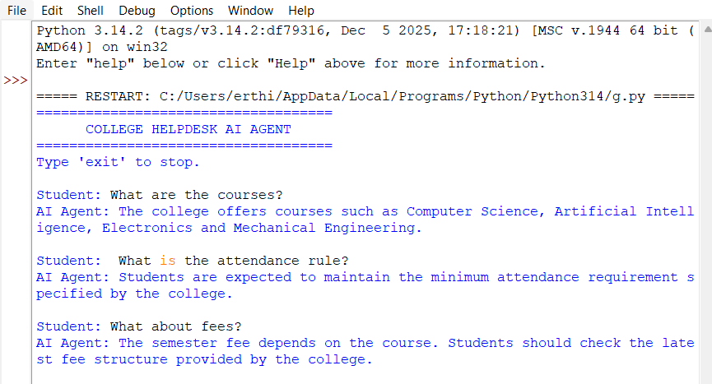

Advantages
- 24×7 support
- Fast query response
- Reduces staff workload
- Accurate information retrieval
- User-friendly interface

38. Multi-Document Enterprise RAG Assistant
Title
Enterprise RAG Assistant for Multi-Document Information Retrieval

Objective
To develop a RAG system capable of processing PDF, DOCX, and TXT documents and answering user questions by combining information from multiple sources.

Problem Statement
Organizations maintain information in different document formats. Searching manually is difficult. A RAG assistant provides accurate answers by retrieving information from all documents.

Input Documents
- PDF Reports
- DOCX Policies
- TXT Files
- User Manuals
- Guidelines

Technologies Used
- Python
- LangChain
- FAISS / ChromaDB
- OpenAI / Gemini API
- PyPDF2
- python-docx

Architecture
Multiple Documents
(PDF + DOCX + TXT)
↓
Document Loader
↓
Text Chunking
↓
Embeddings
↓
Vector Database
↓
Retriever
↓
Large Language Model
↓
Generated Answer
Workflow
- Load PDF, DOCX, and TXT files.
- Extract text.
- Divide into chunks.
- Create embeddings.
- Store vectors.
- Retrieve relevant chunks.
- Generate final answer.
Simple Code

# MULTI-DOCUMENT ENTERPRISE RAG ASSISTANT

print("======================================")
print(" MULTI-DOCUMENT ENTERPRISE RAG")
print("======================================")

# Knowledge from multiple documents
documents = {
"Company Document":
"""Company working hours are 9 AM to 6 PM.
The company provides employee training programs.
Employees must follow company rules.""",

"Policy Document":
"""Employees get 15 days of annual leave.
Leave must be approved by the manager.
Employees must maintain professional conduct.""",

"Report Document":
"""The company completed 25 projects in 2025.
The company has development and testing departments.
The company plans to expand in 2026."""
}

def search_documents(question):

question = question.lower()

best_document = ""
best_score = 0
best_answer = ""

for name, text in documents.items():

score = 0

words = question.split()

for word in words:

if len(word) > 2 and word in text.lower():
score += 1

if score > best_score:
best_score = score
best_document = name
best_answer = text

return best_document, best_answer

print("\nDocuments loaded:")
for name in documents:
print("-", name)

print("\nType 'exit' to stop.")

while True:

question = input("\nEnter your question: ")

if question.lower() == "exit":
print("Thank you!")
break

document, answer = search_documents(question)

if document == "":
print("Assistant: Sorry, no relevant information found.")

else:
print("\nAssistant:", answer)
print("Source:", document)

Example Queries
Query | Source
What is leave policy? | DOCX
What is attendance rule? | PDF
What are office timings? | TXT
Explain project guidelines | Multiple documents

Advantages
- Supports multiple file formats
- Faster document search
- Reduced manual effort
- Accurate responses
- Scalable architecture

Architecture Diagram
PDF + DOCX + TXT
↓
Document Loader
↓
Text Cleaning
↓
Text Chunking
↓
Embedding Model
↓
Vector Database
(FAISS/ChromaDB)
↓
Retriever
↓
LLM (GPT/Gemini)
↓
Generated Answer

Expected Outcome
- The developed AI systems provide accurate, document-based answers for educational and enterprise environments by integrating Retrieval-Augmented Generation with vector databases and Large Language Models.

RUBRICS FOR CALCULATION
Criteria | Weightage | Level 4 – Exemplary | Level 3 – Proficient | Level 2 – Developing | Level 1 – Beginning
Pipeline Functionality | 30% | Correct RAG pipeline — embeddings, retrieval and generation all function coherently | Pipeline mostly correct with minor gaps | Pipeline only partially functional | Pipeline non-functional or conceptually flawed
Answer Relevance & Groundedness | 25% | Retrieves relevant context and generates accurate, grounded answers | Mostly relevant/accurate answers | Inconsistent relevance or accuracy | Answers largely irrelevant or hallucinated
Query Robustness | 20% | Robust handling of varied queries and documents | Handles most queries well | Handles only simple queries | Fails on basic queries
End-to-End Demo | 15% | Smooth, well-demonstrated end-to-end system | Demo mostly smooth, minor hiccups | Demo has noticeable issues | Demo fails or is not ready
Architecture Explanation | 10% | Clear architecture diagram and explanation of design decisions | Adequate explanation of design | Minimal explanation of design | No explanation of design provided

Marks Evaluation:
Question No. | Pipeline Functionality(30%) | Answer Relevance & Groundedness (25%) | Query Robustness(20%) | End-to-End Demo(15%) | Architecture Explanation (10%) | Total Marks (100)
Q1
Q2
Overall Total (100)

